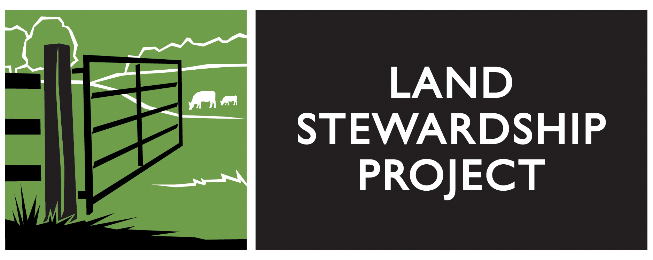
Job Announcement

Job Title: Soil Health Program Organizer
Reports To: Soil Health Program Co-Director
FLSA Status: Exempt
Hours: 40-45 hours/week, including occasional evenings/weekends
Salary Range: $36,000-$44,000 depending on qualifications
Location: Lewiston, MN office

Summary: The Land Stewardship Project (LSP) is a grassroots membership organization, based in Minnesota, with a mission of fostering an ethic of stewardship for farmland, promoting sustainable agriculture, and developing healthy communities. LSP uses a community organizing, education-to-action approach with the goal of achieving major change in our agriculture and food system towards stewardship, economic and racial justice & community vitality. We have 4300 member-households.
LSP seeks a full-time staffperson to join our Bridge To Soil Health organizing team, based in southeast Minnesota (Lewiston). This initiative works directly with, and expands, a strong network of mid-sized crop and livestock farmers in the region that wish to make on-farm changes that build soil health and organic matter levels, improve yields, sequester carbon, and enhance water quality and family farm profitability. The initiative also engages farmers in public policy discussion and prioritizing of much-needed public policy reforms that support soil health, improved conservation, and more farmers on the land. The Bridge to Soil Health team consists of four core members plus administrative and communication support.
Essential Functions:
- Conduct 1 to1 farm visits.
- Lift up farmer stories and voices through digital communication and social media including Facebook and YouTube.
- Organize and facilitate soil-building workshops, soil health hubs, grazing circles, and grazing education.
- Develop knowledge of soil-building methods, their on-farm financial potential, and their on-farm applicability.
- Help expand LSP’s soil builders’ network of farmers wanting more information, and work with farmers interested in making changes on their own farms.
- Create video shorts and develop fact sheets of soil health farming methods.
- Recruit additional LSP farmer members.
Supervisory Responsibilities: None.
Necessary Skills/Education/Experience:
- Experience in commercial scale crop and livestock production, and ability to relate well to farmers. Livestock farming background and direct experience with intensive, rotational grazing is preferred.
- Knowledge of, and deep interest in, the growing range of soil-building methods being demonstrated by farmers in the upper Midwest, including cover crops, no-till, and intensive grazing.
- Proficiency with electronic communication tools, including e-mail, social media, digital photography and video, and the ability to lift up farmer stories and voices through digital communication and social media including Facebook and YouTube.
- Commitment to the importance of farmer-to-farmer learning.
- Excellent oral and written communication skills.
- Commitment to the vision, goals and community organizing methods of LSP http://landstewardshipproject.org/about/mission.
- Valid driver’s license, access for a reliable vehicle, and willingness to travel regionally.
Preferred qualifications:
- Group workshop facilitation and public speaking skills
- Outgoing personality, telephone skills, community organizing and/or sales experience, a track record of working well in a team setting, and a good sense of humor.
- Education and training in soils, biology, agronomy, animal science or agriculture education.

Work Environment: This job operates partly in an office environment, with an open office plan. This role routinely uses standard office equipment such as computers, phones, photocopiers, and filing cabinets. This job also requires being on the road, visiting with farmers on their farms, and in community spaces organizing for farmer training. Traveling outside the state for conferences and meetings with allies and partners is a possibility and may require airplane travel.
Physical Demands: This is largely a sedentary role; however, other physical demands could occasionally include setting up for events, food hauling and preparation, loading and unloading materials for trainings, setting up tables and chairs, tabling at outreach events and filing. This would require the ability to carry 20-60lbs, lift files, open filing cabinets and bend or stand as necessary.
How to Apply: Please submit cover letter & resume to jobs@landstewardshipproject.org, Attn: Shona Snater. Application deadline: March 6, 2020.

